#### 

#### Starz of Tomorrow Baseball Academy

**2020 St. Cloud Camp**

**Thursday, August 20th**

**10:00-3:00pm, baseball players 6-13 years old**

**10:00am-2:00 Skills Camp & GAME from 2:00-3:00pm! Lunch, camp T-shirt & award**

**COVID-19:Safety will be our top priority!**

All MDH COVID-19 policies will be followed with a screening and waiver.

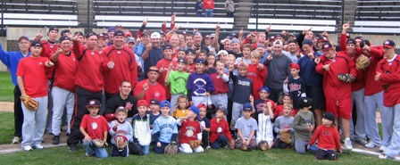

**Directed by St. Cloud State Head Coach, Pat Dolan, the 2015 and 2016 NCBWA Central Region Coach of the Year and 2016 National Coach of the Year and his coaching staff!**

**Joe Faber Field, St. Cloud, MN**

Register On line at: www.StarzBaseballCamp.com

Or mail this form with payment to Starz of Tomorrow:

PO Box 2063, St. Cloud, MN 56302

***Pat Dolan @ 320-333-3336 or*** ***Pat@StarzBaseballCamp.com***

### REGISTRATION Deadline August 1, 2020

Registration: __$50 __ $25 for 2nd player in family

***Skills Camps Features*:**

• Instruction on throwing, fielding, hitting, pitching, base running and more! Drillz, Drillz, Drillz to improve SKILLZ!

• Individual position practice, emphasis on skill development and having FUN playing this great game!

• Lunch provided daily along with a Starz of Tomorrow Baseball Academy T-shirt and participation award!

* Skill Testing in the 60 yard dash, home-to-1st base, position work, on field batting practice, radar gun speed

### Registration Information:

Participant’s name: ______________________________________________________________

Position #1 ___ #2____Ht _____Wt ____Bat ___Throw __

Family Address _________________________________________City _____________ Zip ___

Daytime Phone _______________E-Mail **(please print clearly!)**_______________________________

**Medical Information**

Doctor__________________________________Phone_________________________________

Insurance coverage________________________________________________________

Statement of Release: I agree to release the Starz of Tomorrow Baseball Academy and all their employees of all liability related to accidents or injuries which may occur while participating in the above activity. I also give permission for emergency medical procedures to be administered if I cannot be contacted in case of an emergency.

Parent/Guardian signature __________________________________Date________________________________________________

