
13th Annual Waite Park Youth Baseball Summer Camp
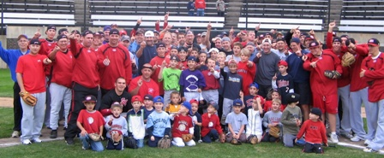

Who: Baseball Players ages 6-14, Boys & Girls Invited!
What: An Instructional & FUN Baseball Camp
With the SCSU Baseball Staff Lead by Head Coach, Pat Dolan
When: Monday, June 9
Time: 10:00am–3:00 with a baseball lunch, camp t-shirt & awards!
Where: River’s Edge Baseball Complex, Waite Park, MN
Cost: $100 (2nd child in family $50)
($25 deposit to hold your spot! You still need to register online)
For more info contact: Pat Dolan @ 320-333-3336 Pat@StarzBaseballCamp.com
www.StarzBaseballCamp.com

Come join us in some baseball fun and learn to play the game the right way!
BASEBALL DRILLZ, DRILLZ, DRILLZ to improve BASEBALL SKILLZ w/ the Starz!



