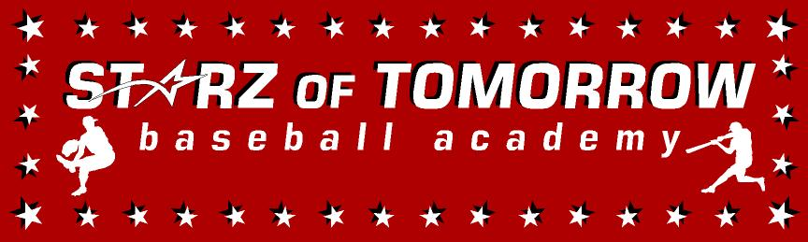

2025 STARZ HIGH SCHOOL WINTER/SPRING TRAINING DEVELOPMENTAL PROGRAM

“GET READY FOR YOUR HIGH SHOOL BASEBALL” @ THE SCSU HUSKY DOME!

Players in Grades 9-12th grade/11:00am-1:30pm: 25 hours of baseball!
Saturday’s, January 18, 25, February 1, 8, 15, March 1, 8, 15
AND Monday’s, January 20 and February 17

(AND AN OPTIONAL 2nd MIDWEEK TEAM DAY@ YOUR HIGH SCHOOL)

*Pre-and post-practice mobility session to increase flexibility and performance and reduce injury!
*LIVE hitting off the Hack Attacks in both the batting cages and LIVE BP on the field
*Blast Motion bat speed training and anti-rotational drill work
*Radar gun testing on arm strength and bat exit velocity
*Fundamental Pre-season Throwing program
*Specific position practice with NEW drill work in catching, infield, outfield and pitching
*Base running Basics with a Speed/Agility Program to increase foot speed
*Driveline plyo ball training done the right way to increase performance
*Baseball specific strength and conditioning to increase performance
*Sessions on mental imagery & breathing exercises to increase performance
*Nutrition session with weight management both increasing and decreasing body weight
*Analytical testing with Trackman the last few weeks of the program!

SCSU Husky Dome
(The BIGGEST and the BEST Indoor Baseball Facility in the area!)
Directed by the St. Cloud State University Coaching staff lead by the
NCBWA National Coach of the Year, Pat Dolan!
10 sessions/25 Hours of Fundamental Skill Development Getting you ready for your High School baseball season! COME JOIN THE FUN IN THE HUSKY DOME!
Learn from the Best to Beat the Rest!
“FUN & FUNdamentals is the name of our game since 1991!
25,000+ players served; 250+ moving on to college ball! And 20 to pro ball! Are U NEXT?!!!!

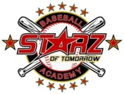

******************************************************************************

OPTIONAL Midweek Training TEAM DAY information:
Want to throw harder, spin it better, stay healthy & have more fun playing the great game of “BASEBALL?” Learn how with current SCSU Pitching Coach and former Driveline Baseball Pitching Trainer, SJ (Coach Moose) Mousseau.
These sessions will include:
Custom Throwing Program, Trackman Data &Analysis, Lifting & Mobility, Skills to improve the mental game

(Call 320-333-3336 for TEAM INFORMATION and dates/times specific to your requests and facilities)

2025 STARZ HIGH SCHOOL WINTER/SPRING TRAINING DEVELOPMENTAL PROGRAM REGISTRATION FORM

Pay on line at www.StarzBaseballCamp.com click on camps & clinics or
Mail this form with payment to: Starz of Tomorrow
1431 23rd St SE, St. Cloud, MN 56304
For More Information contact @320-333-3336
Pat@StarzBaseballCamp.com or www.StarzBaseballCamp.com

REGISTRATION Fee: $250 for 25 hours ONLY $10 per hour!

January 1; Registrations after this date will be considered on a space available basis & a late fee of $25 will be added

Participant’s Name __________________________ Grade ____ School ___________________________

Family Address_____________________________ City _____________Zip _______________________

Daytime Phone______________________ E-Mail (print clearly!)________________________________
Medical Information
Doctor ___________________Phone__________ Any medical conditions? ________________________
Insurance coverage______________________________________________________________
Statement of Release: I agree to release the Starz of Tomorrow Baseball Academy and all their employees of all liability related to accidents or injuries which myself or a member of my family may incur while participating in the above activity. I also give permission for emergency medical procedures to be administered if I cannot be contacted in case of an emergency.
Parent/Guardian signature __________________________________Date________________

Keep this portion for your records
- Sessions in each area of baseball including a 15 minute classroom style baseball “chalk talk” and 30 minute lifting session
- Each player will get 100+ swings in the batting cages and batting tees and soft toss drills
- Sessions on baseball agility and strength training, arm care and prevention and the mental side of baseball
- Great baseball instructions from the SCSU baseball staff and players and other area coaches
- Clinic t-shirts and protective equipment will be provided, but you can bring your own equipment
- Arm Care: Rotator cuff strengthening, Driveline Play weighted balls, velocity training
- What will you need to bring? Tennis shoes, glove, baseball playing apparel, and get ready for lots of baseball fun.
- More specific details on both the High School Winter/Spring Developmental Training Program is on our web page @: www.StarzBaseballCamp.com

COME JOIN THE BASEBALL FUN AND PLAY THE HUSKIES WAY with the SCSU coaching staff!

