
2025 Shakopee Youth Baseball Summer Camp
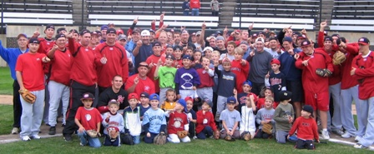

Who: Baseball Players ages 6-14, Boys & Girls Invited!
What: An Instructional & FUN Baseball Camp
With the SCSU Husky Baseball Staff and players
When: Tuesday, June 17th
Time: 10:00am – 3:00pm with baseball lunch provided
Where: Tahpah Park Fields 1-4
Cost: $100 & 2nd child in family $50
($25 deposit to hold your spot. You must register on line)

For more info contact: Pat Dolan at 320-333-3336 or Pat@StarzBaseballCamp.com
www.StarzBaseballCamp.com
Come join us in some baseball fun and learn to play the game the right way!
BASEBALL DRILLZ, DRILLZ, DRILLZ to improve BASEBALL SKILLZ with the Starz!
Who is going to be the next Sheldon Miks, Zak Hoffmann or Chirs Kubitz to Huskyland?

