

Starz of Tomorrow Baseball Academy
2nd Annual 2025 Shakopee Youth Baseball Camp
Tuesday, June 17th, 10-3:00pm Players 6-14, Boys & Girls Invited!
10:00am-2:00 Skills Camp & GAME from 2:00-3:00pm!
Baseball Lunch, camp T-shirt & awards!
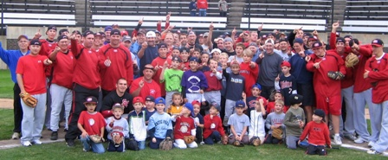
Directed by SCSU Head Coach, Pat Dolan, the 2015 and 2016 NCBWA Central Region Coach of the Year and 2016 National Coach of the Year and his staff!
Shakopee’s Sheldon Miks, Zak Hoffmann and Chris Kubitz played @ SCSU
R U NEXT?!
Location: Tahpah Park Fields 1-4
Register On line at: www.StarzBaseballCamp.com
($25 deposit to hold spot! You must register online)
Pat Dolan @ 320-333-3336 or Pat@StarzBaseballCamp.com

REGISTRATION Deadline June 1, 2025
Registration: __$100 Shakopee players __ $50 2nd family members
Skills Camps Features:
• Instruction on throwing, fielding, hitting, pitching, base running and more! Drillz &, Drillz to improve Baseball SKILLZ!
• Individual position practice, emphasis on skill development
• Lunch provided
- Camp T-shirt & participation award and Camper of the Day, Charlie. Hustle, Mr. Defense and MVP awards for each group
- Skill Testing in the 60 yard dash, home-to-1st base, position work, on field batting practice, radar gun speed and exit velo
- NEW!! Rapsodo providing base metrics for hitters and position players (spin rate, launch angle, exit velo, x & y axis for pitches, run value, etc.).

Registration Information:
Participant’s name: ______________________________________________________________

Position #1 ___ #2____Ht _____Wt ____Bat ___Throw __
Family Address _________________________________________City _____________ Zip ___
Daytime Phone _______________E-Mail (please print clearly!)_______________________________
Medical Information
Doctor__________________________________Phone_________________________________
Insurance coverage________________________________________________________
Statement of Release: I agree to release the Starz of Tomorrow Baseball Academy and all their employees of all liability related to accidents or injuries which may occur while participating in the above activity. I also give permission for emergency medical procedures to be administered if I cannot be contacted in case of an emergency.
Parent/Guardian signature __________________________________Date________________________________________________

