
Hutchinson Youth Baseball Summer Camp
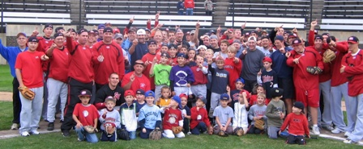

Who: Baseball Players ages 6-14, boys & girls!
What: An Instructional & FUN Baseball Camp
With the SCSU Husky Baseball Staff and players
When: Thursday, June 5th
Time: 10:00am – 3:00pm with a baseball lunch provided!
Where: Roberts Park, Hutchinson MN
Cost: $100 per player; 2nd child in family $50
$25 deposit to hold your spot! You Still need to register online

For more info contact: Pat Dolan at 320-333-3336 Pat@StarzBaseballCamp.com
www.StarzBaseballCamp.com

Come join us in some baseball fun and learn to play the game the right way!
BASEBALL DRILLZ, DRILLZ, DRILLZ to improve BASEBALL SKILLZ with the Starz!
Who is going to be the next Tyler Schiller to Huskyland?

