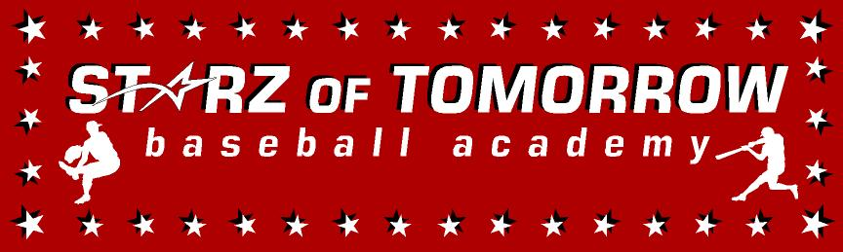
7th Annual Foley Youth Baseball Summer Camp
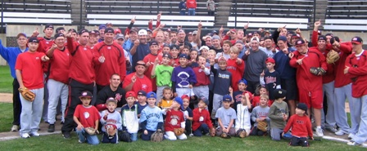

Who: Baseball Players ages 6-14, Boys & Girls Invited!
What: An Instructional & FUN Baseball Camp
With the SCSU Husky Baseball Staff and players
When: Tuesday, June 10th
Time: 10:00am – 3:00pm with a baseball lunch provided
Where: Foley HS, Field 4, Foley, MN
Cost: $100 per player; 2nd child in family $50
($25 deposit to hold your spot. You Still need to register online)

For more info contact: Pat Dolan at 320-333-3336 Pat@StarzBaseballCamp.com
www.StarzBaseballCamp.com

Come join us in some baseball fun and learn to play the game the right way!
BASEBALL DRILLZ, DRILLZ, DRILLZ to improve BASEBALL SKILLZ with the Starz!
Who is going to be the next Trey Emmerich, Drew Beier or Ian VonWald to Huskyland?

