
2025 Aitkin Youth Baseball Summer Camp
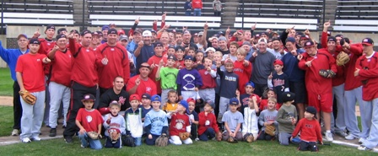

Who: Baseball Players ages 6-14, Boys & Girls invited!
What: An Instructional & FUN Baseball Camp
With the SCSU Husky Baseball Staff and players
When: Thursday, June 26th
Time: 10:00am – 3:00pm with baseball lunch provided
Where: Woock Field on Bill Cline Way
Cost: $100 Aitken players/$50 2nd child in family
($25 deposit to hold spot! You must register online)

For more info contact: Pat Dolan at 320-333-3336 or Pat@StarzBaseballCamp.com
www.StarzBaseballCamp.com
Come join us in some baseball fun and learn to play the game the right way!
BASEBALL DRILLZ, DRILLZ, DRILLZ to improve BASEBALL SKILLZ with the Starz!

